241761 Methodology

asdddddddddddddddddddddddddddddddddddddddddddddddddddddddddddddddddddddddddddddddddddd

hhhhhhhhhhhhhhhhhhhhhhhhhhhhhhhhhhhhhhhhhhhhhhhhhhhhhhhhhhhh

1. **Methodology:**

**3.1 Process:**

The process starts when the user clicks the *"Add Movie"* button. Then the user is taken to the *"add"* page, where he finds an input element where he enters the movie's name. This click triggers an API call and renders the options similar to the keyword. All the options are generated with the release date after the title. (format: "*<MOVIE NAME> - <RELEASE DATE>*".)

The user selects his desired title and gets redirected to the *"edit"* page, where he adds his review and rating. And then, he saves the rating and review, and the movie gets added to the home page.

The simulation mentioned above flow is from the user's point of view. the technical aspect of what happens is given below:

First, the index page gets rendered by querying all the movies from the database. Then, if a user wants to add a new film, he clicks on the *"Add movie"* button. Next, the app redirects him to the *"/add"* path, where he finds a form of an input field and a submit button.

Next, the user enters a movie name and hits *"Add movie."* It triggers an API call *(GET)* which fetches all the possible matches and renders the movie titles and their release date in the format of *"<MOVIE TITLE> - <RELEASE DATE>,"* which are hyperlinks that point to the URL which leads to the edit page which makes another API call *(GET)* with the movie ID and gets the data of the movie.

Finally, the user adds the rating and review of the movie he just added, which triggers a database insertion of the film, and the movie gets stored in the database.

llllllllllllllllllllllllllllllllllllllllllllllllllllllllllllllllllllllllllllllllllllllllllllllllllllllllllllllllllllllllllllllllllllllllllllllllllllllllllllllllll

444444444444444444444444444444444444444444444444444444444444444444444444444444444444444444

456546456546666666666666666666666666666666666666666666666666666666666666666666666645444444

Gujarat Technological University 4 Government Engineering College-Rajkot

4566666666666666666666666644444444444444444444444444444444444444444444444444444444444444

llllllllllllllllllllllllllllllllllllllllllllllllllllllllllllllllllllllllllllllllllllllllllllllllllllllllllllllllllllllllllllllllllllllllllllllllllllll

241761 Methodology

**3.2 Technologies used:**

* ExpressJS (a node framework)
* MongoDB
* EJS (templating Engine)
* Bootstrap

**3.3 File Structure:**

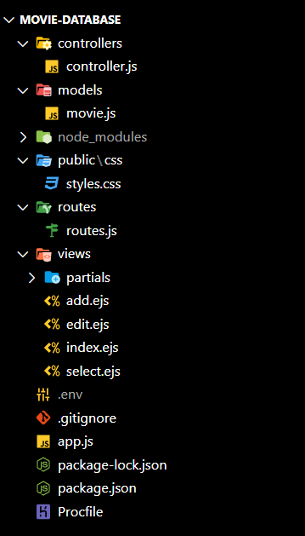

*Fig 3(a). The file structure of the app*

llllllllllllllllllllllllllllllllllllllllllllllllllllllllllllllllllllllllllllllllllllllllllllllllllllllllllllllllllllllllllllllllllllllllllll

Gujarat Technological University 5 Government Engineering College-Rajkot

kllllllllllllllllllllllllllllllllllllllllllllllllllllllllllllllllllllllllllllllllllllllllllllllllllllllllllllllllllllllllllllllllllllllllllllllll

241761 Methodology

**3.4 ER Diagram:**

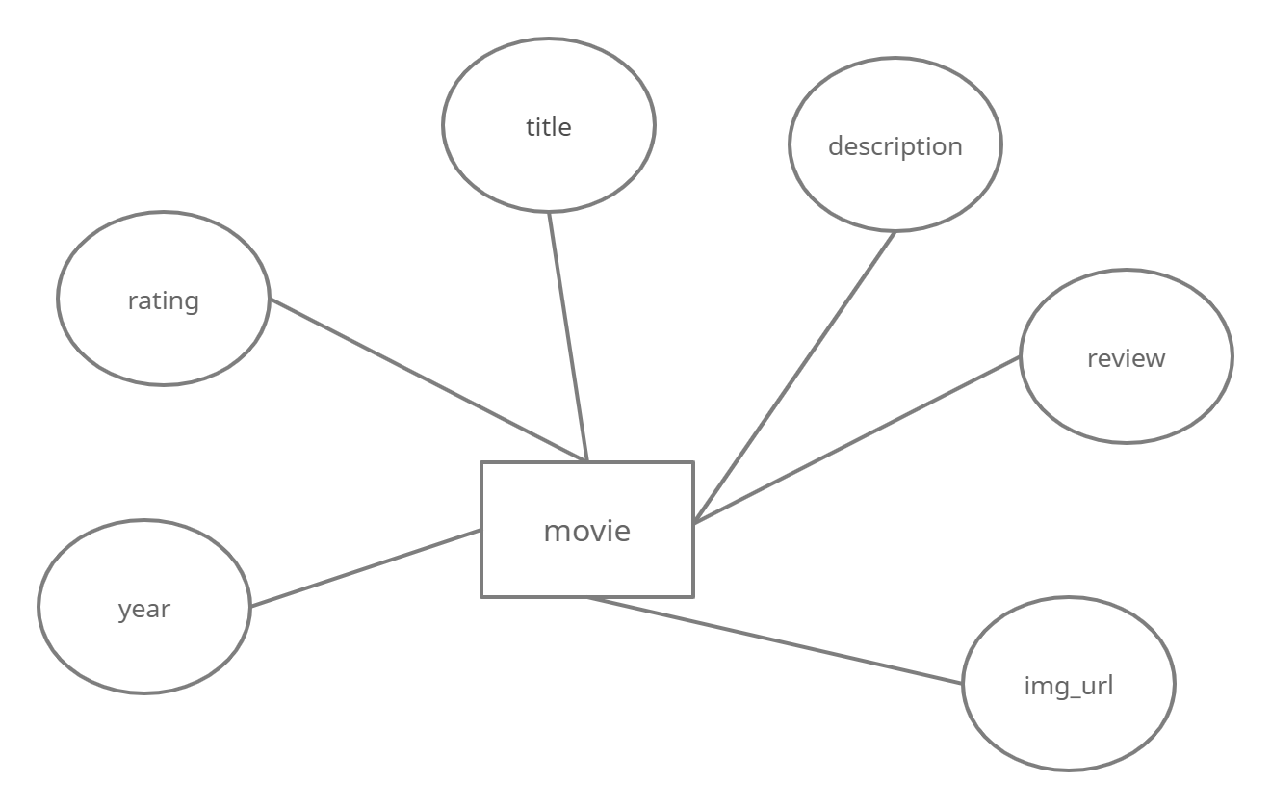

*Fig 3(b). The ER Diagram of the Movie rating and review app*

llllllllllllllllllllllll

Gujarat Technological University 6 Government Engineering College-Rajkot

L;;;;;;;;;;;;;;;;;jhlkkkkkkkkkkkkkkkkkkkkkkkkkkkkkkkkkkkkkkkkkkkkkkkkkkkkkkkjjjjjjjjjjjjjjjjjjjjjjjjjjjjjjjjjj

jjjjjjjjjjjjjjjjjjjjjjjjjjjjjjjjjjjjjjjjjjjjjjjjjjjjjjjjjjjjjjjjjjjjjjjjjjjjjjjjjjjjjjjjjjjjjjjjjjjjjjjjjjjjjjjjjjjjjjjjjjjjjjjjjjjjjjjj

241761 Methodology

hjjjjjjjjjjjjjjjjjjjjjjjjjjjjjjjjjjjjjjjjjjjjjjjjjjhhhhhhhhhhhhhhhhhhhhhhhhhhhhhhhhhhhhhhh

**3.5 Use Case Diagram:**

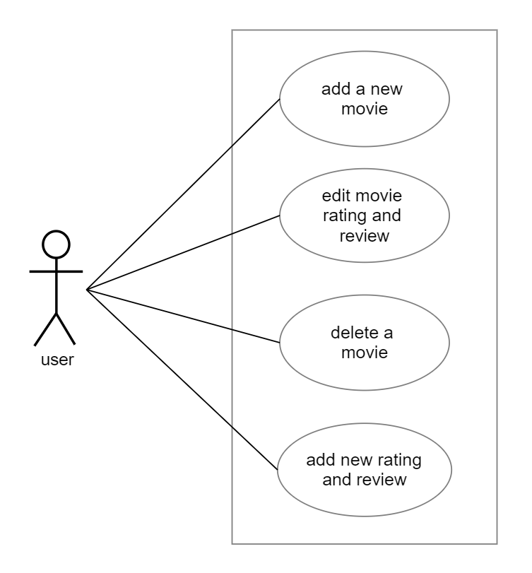

*Fig 3(c). The Use Case Diagram of the Movie rating and review app*

jjjjjjjjjjjjjjjjjjjjjjjjjjjjjjjjjjjjjjjjjjjjjjjjjjjjjjjjjjjjjjjjjjjjjjjjjjjjjjjjjjjjjjjjjjjjjjjjjjjjjjjjjjjjjjjjjjjjjjjjjjjjjjjjjjjjjjjjjjjjjjjjjjjjjjjjj

kkkkkkkkkkkkkkdfjdsfshlgjfgfkjgfdksfdlgjfdkgjfdgkjkjsfldgjkfdlghkf

Gujarat Technological University 7 Government Engineering College, Rajkot